**Power BI**

**Hands-on Assessment**

Shashikant Suman

Scenario: Sales Performance Analysis with Power BI

In this scenario, let's imagine you work for a retail company, and you've been tasked with analyzing the sales performance of your products and stores using Power BI. You have multiple data sources and tables to work with, and your goal is to provide actionable insights to improve sales strategies.

Data Sources:

• Sales Transac7ons Data: Contains information about each sale, including product ID,

store ID, date, quantity sold, and revenue generated.

• Product Data: Includes details about each product, such as product ID, name,

category, and price.

• Store Data: Provides information about the stores, including store ID, location, and

store manager.

**Requirement 1: Data Loading**

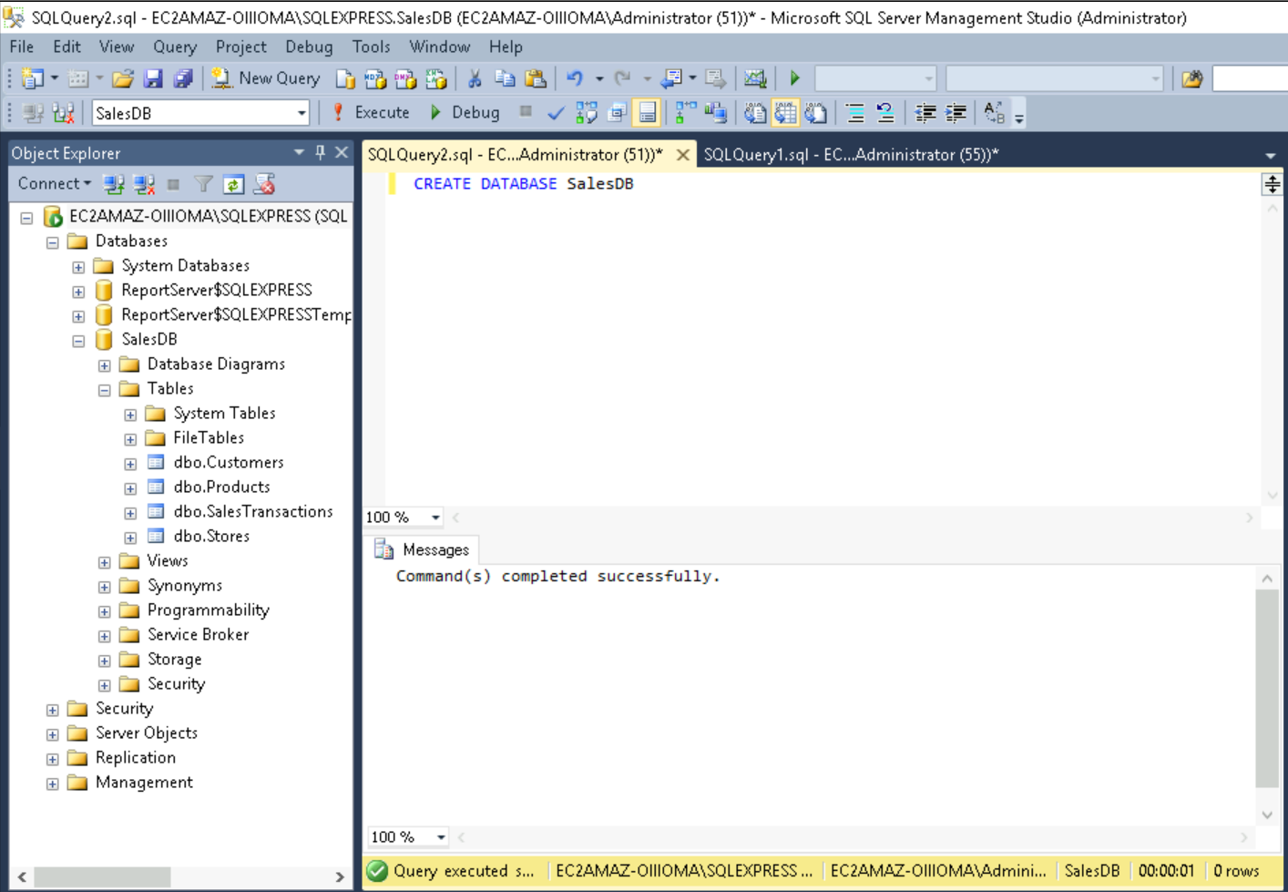

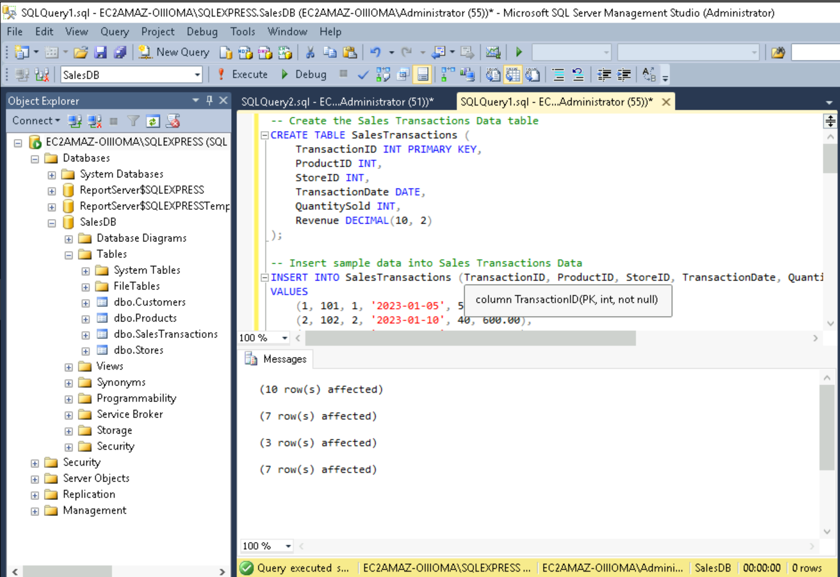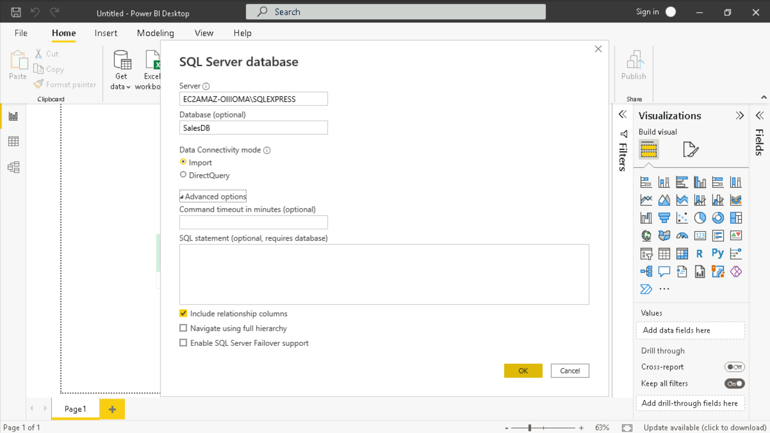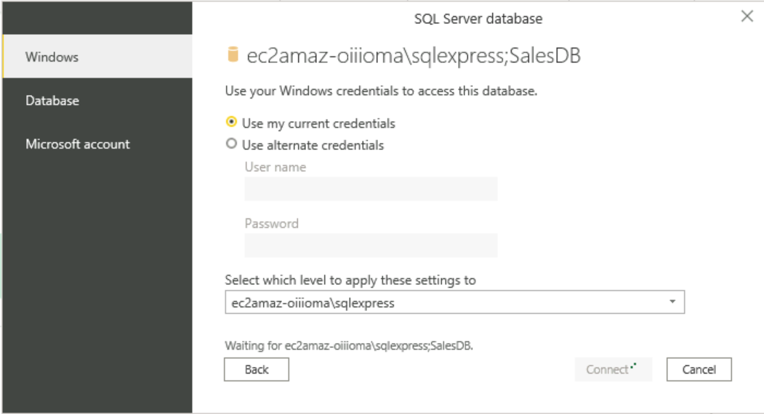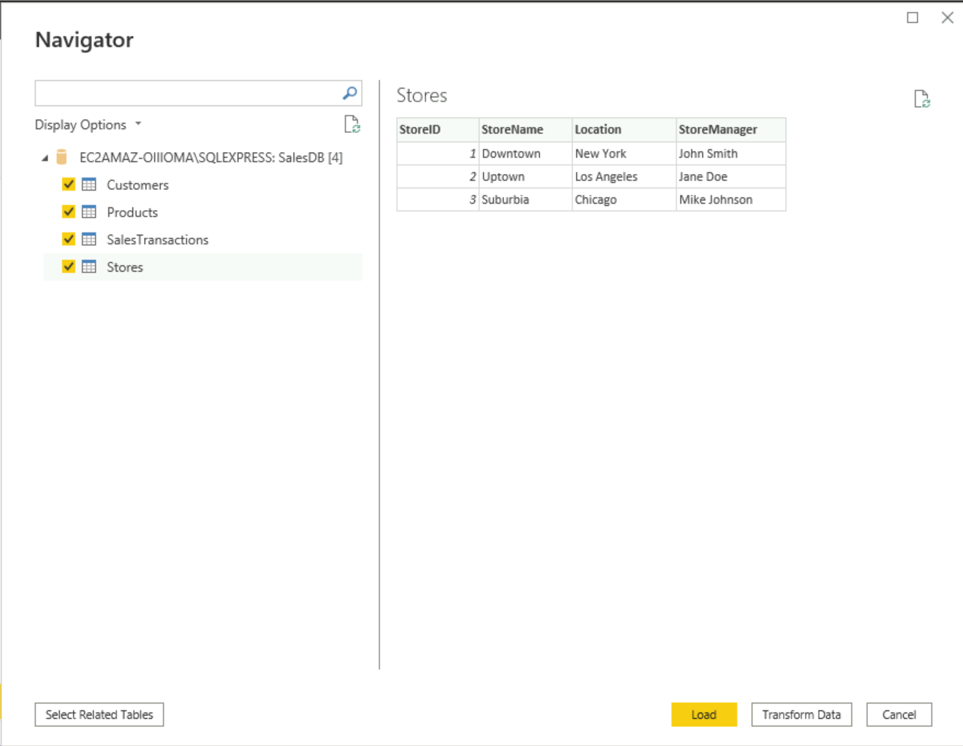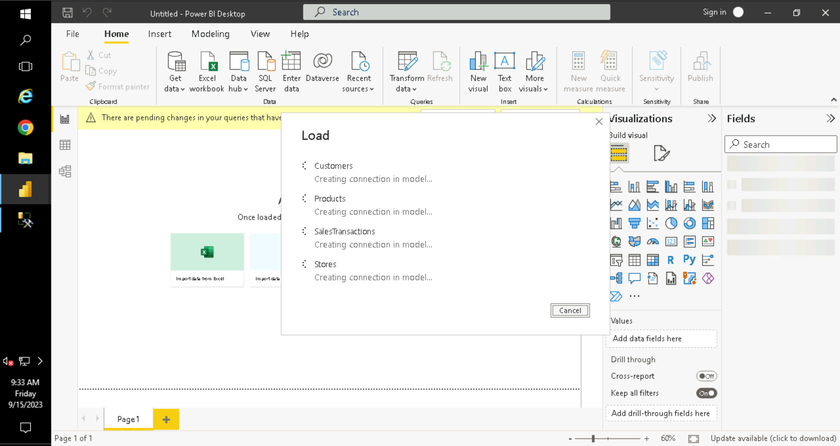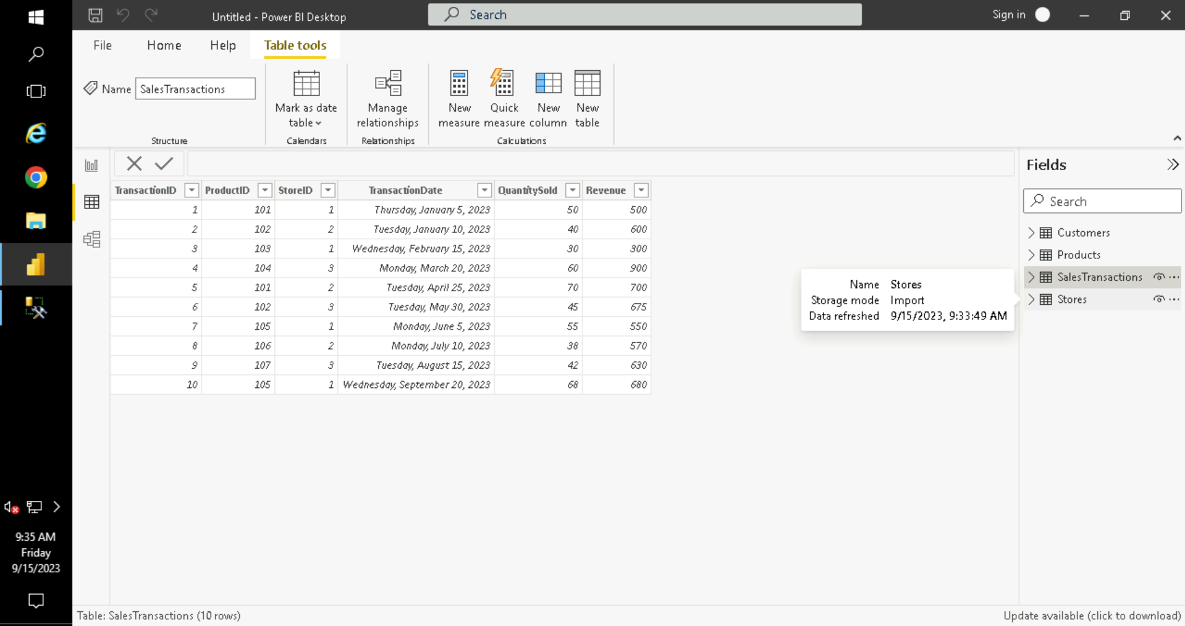

**Requirement 2: Data Transformation**

• Merge Tables:

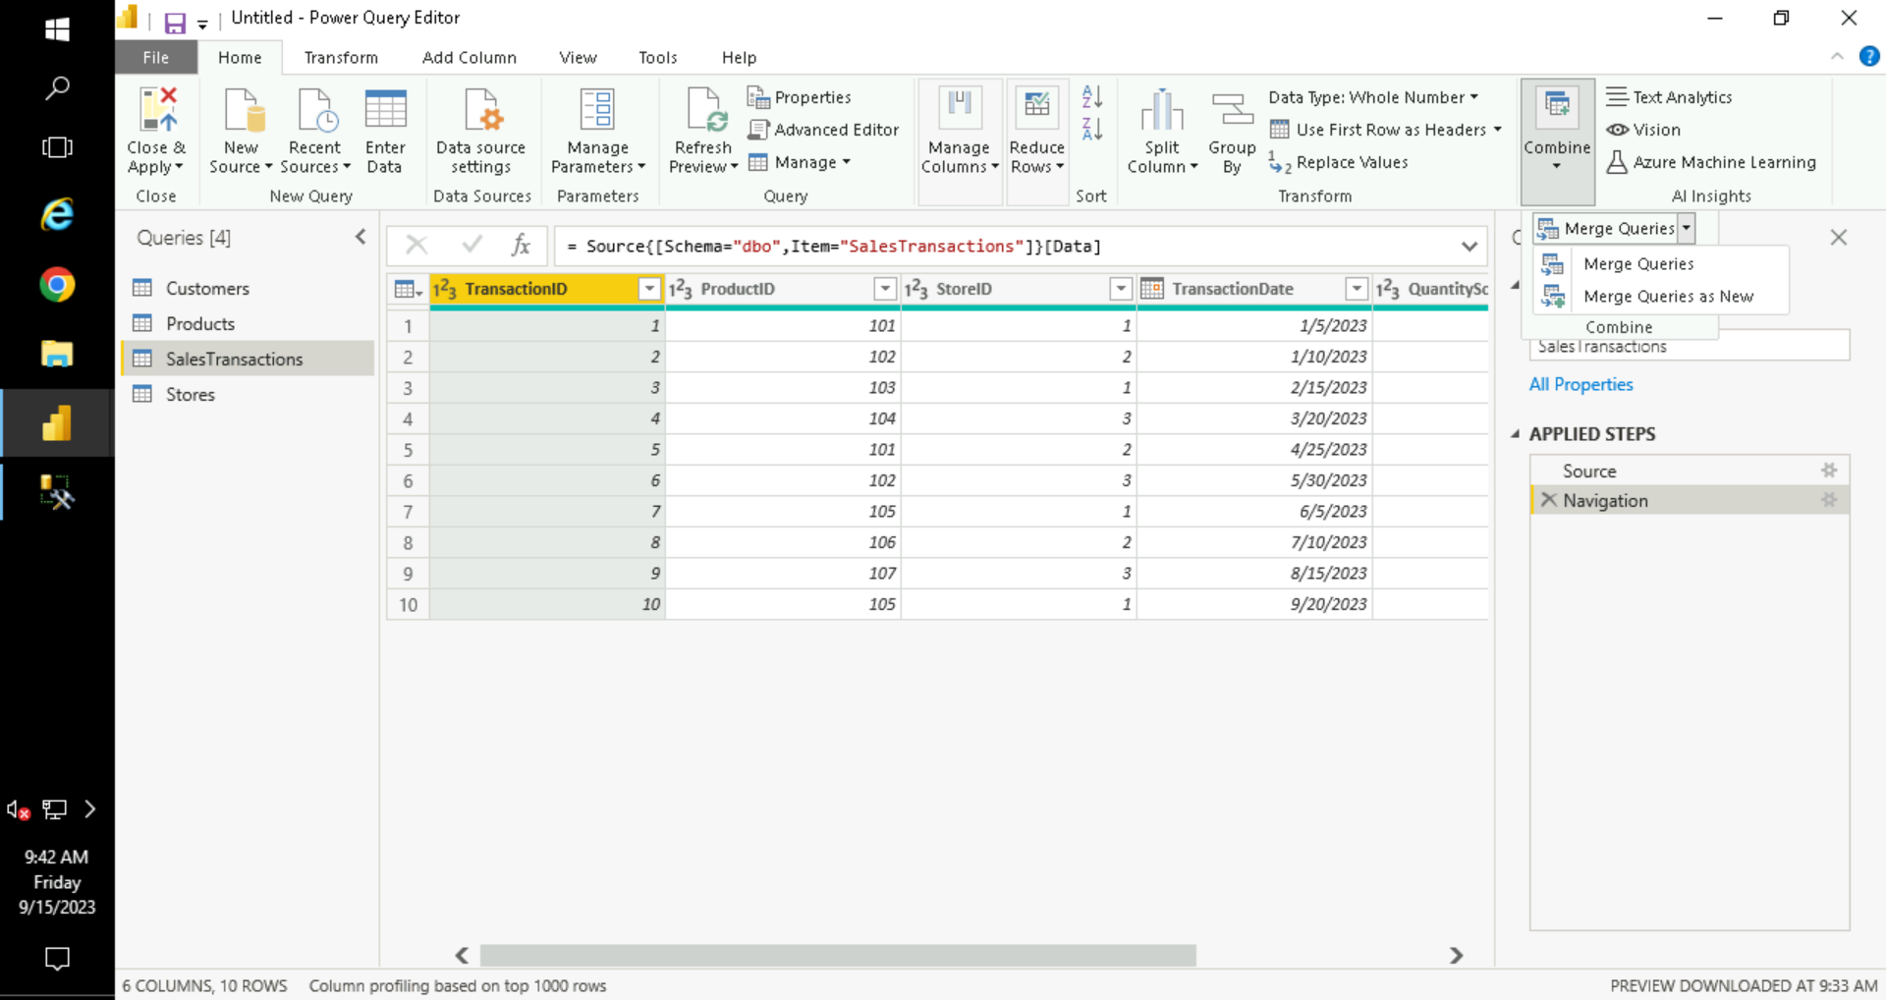

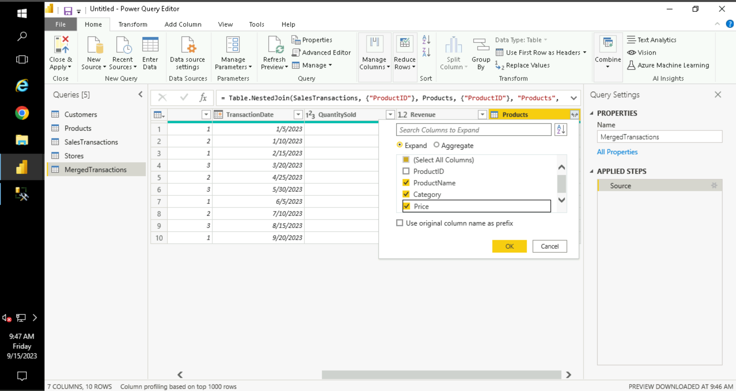

• Clean Data:

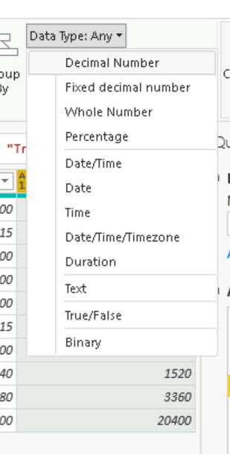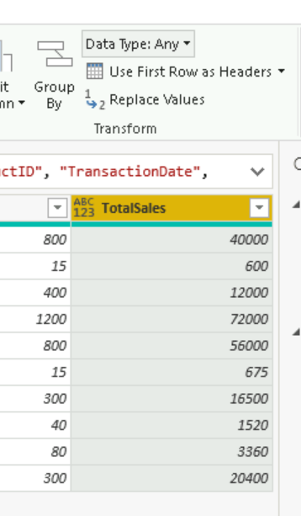

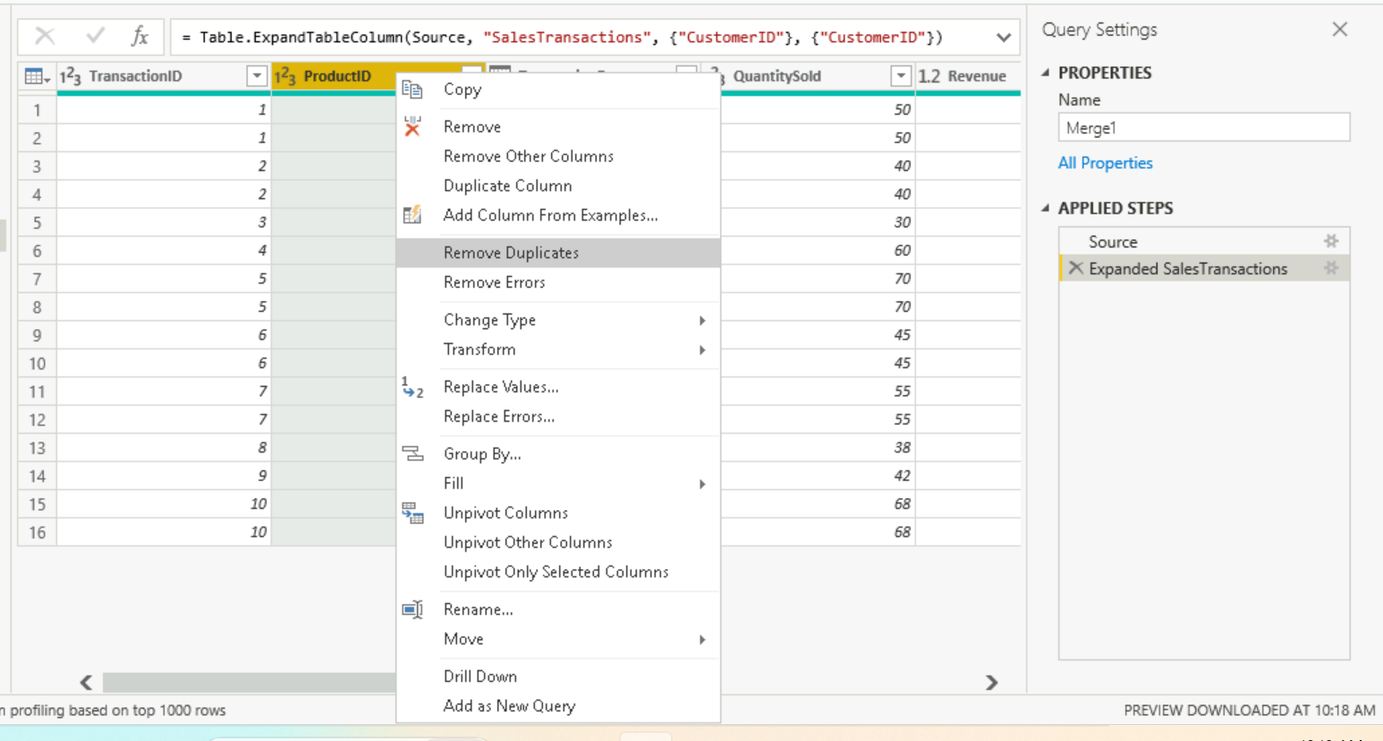

• Create Calculated Columns:

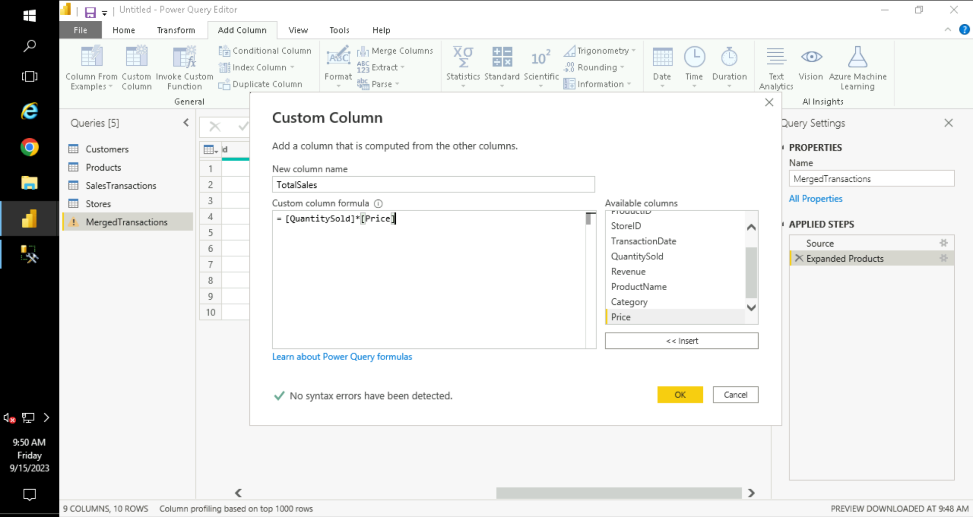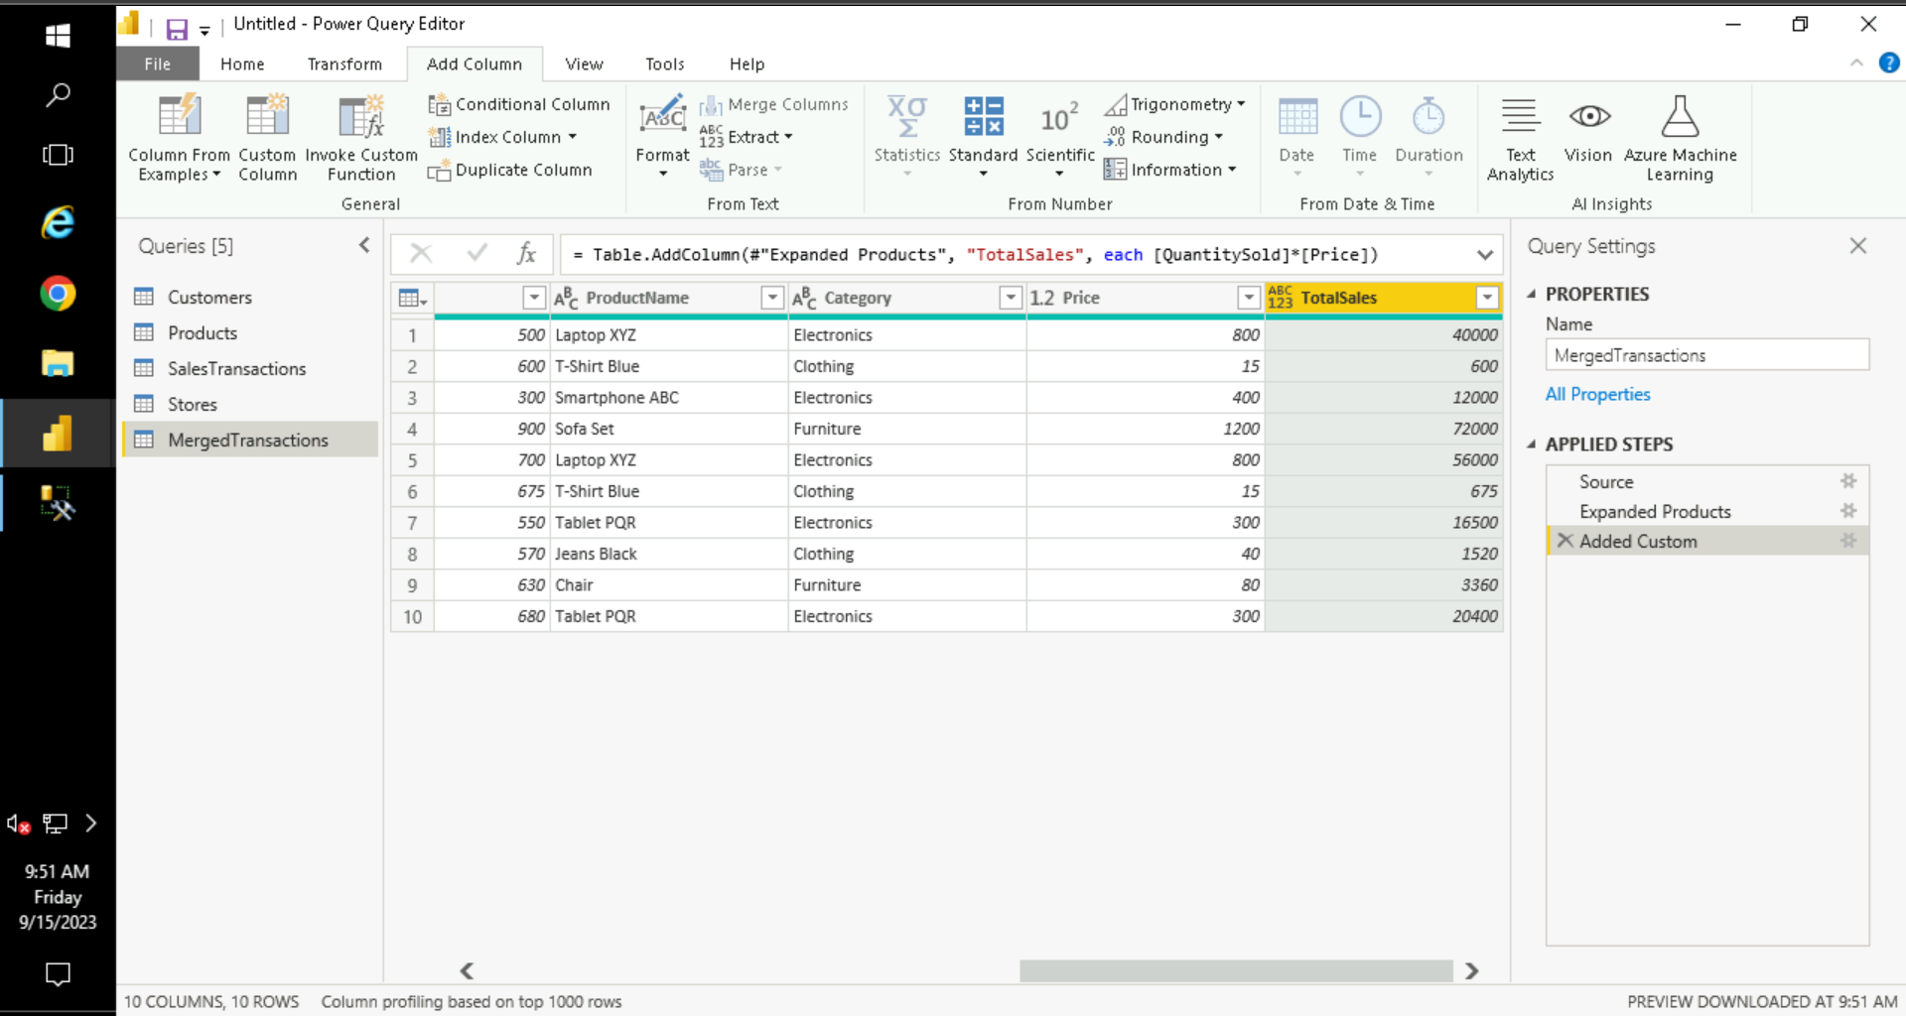

• Filter Data:

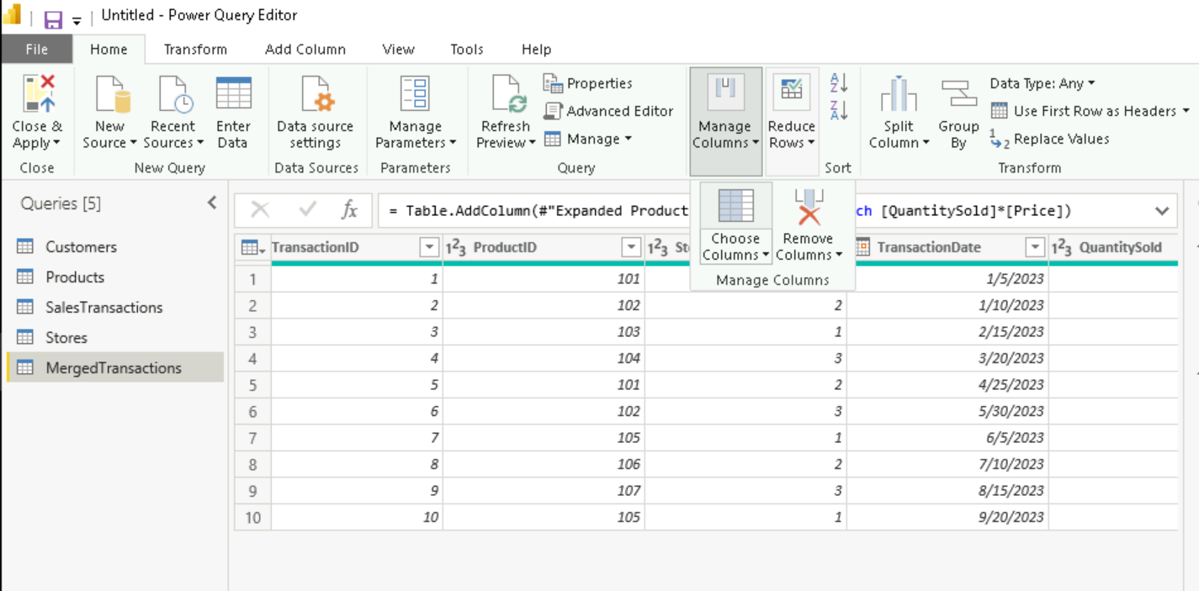

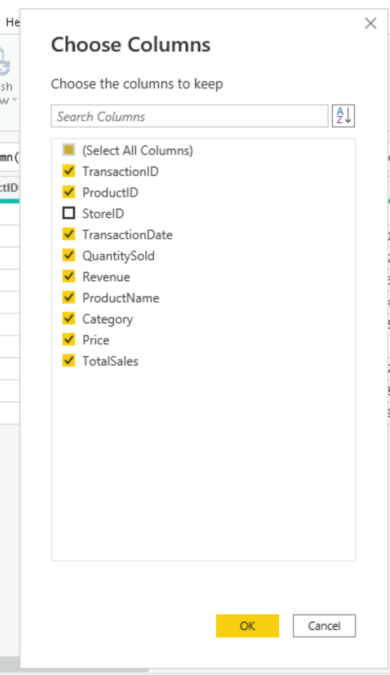

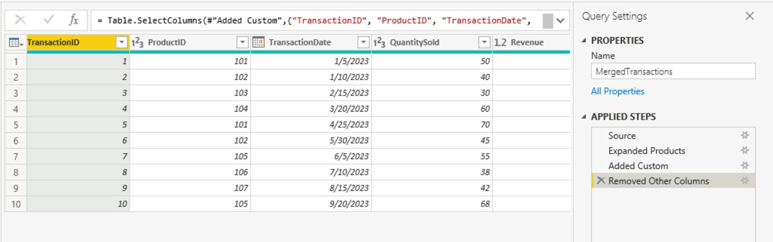

**Requirement 3: Data Modelling**

• Create Relationships:

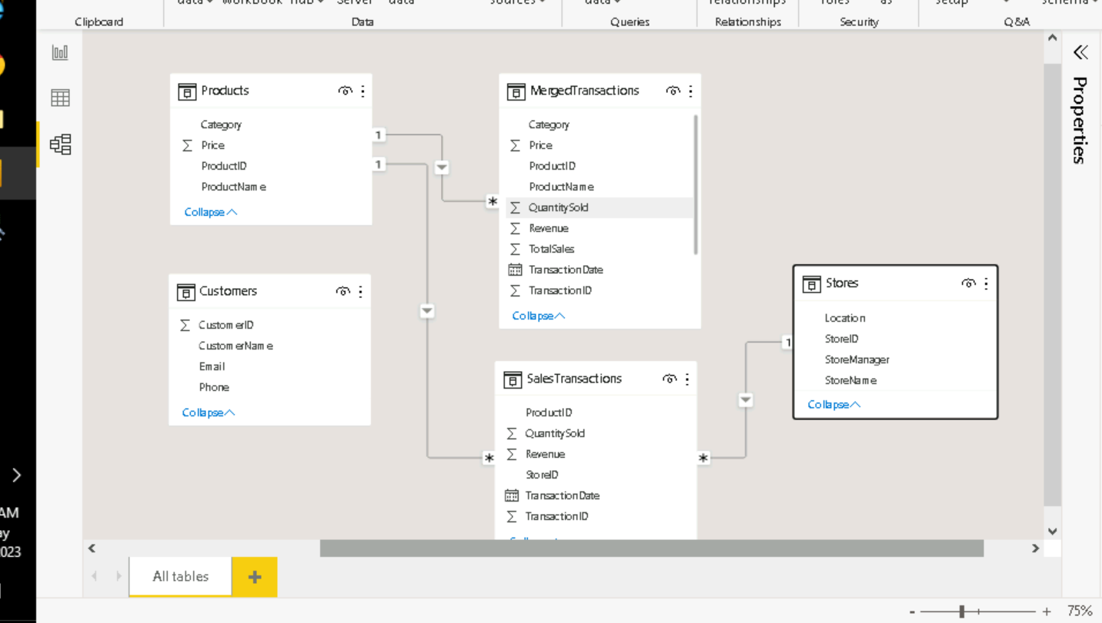

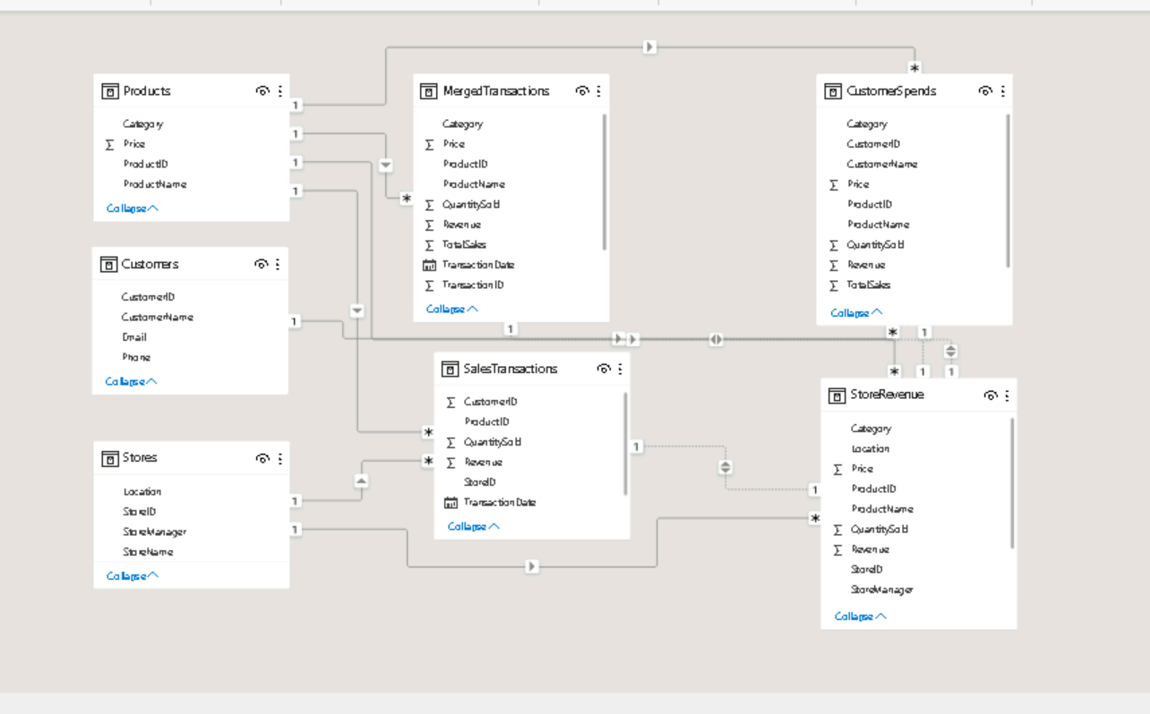

• Create Hierarchies:

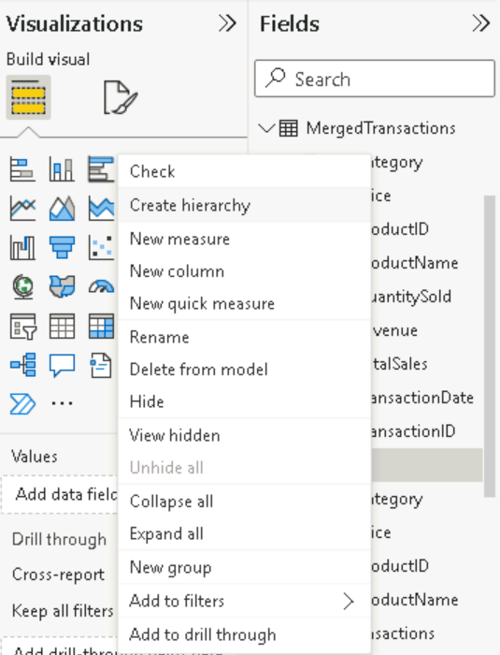

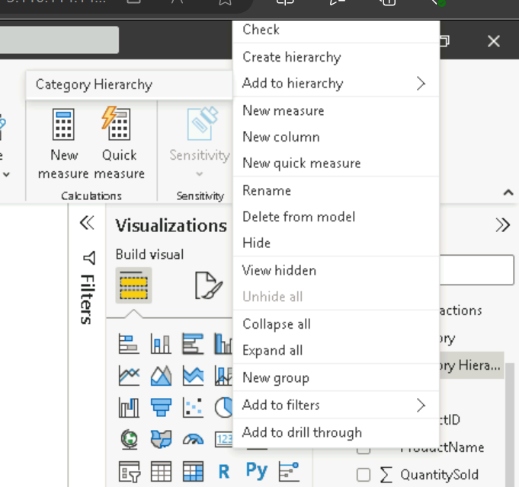

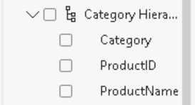

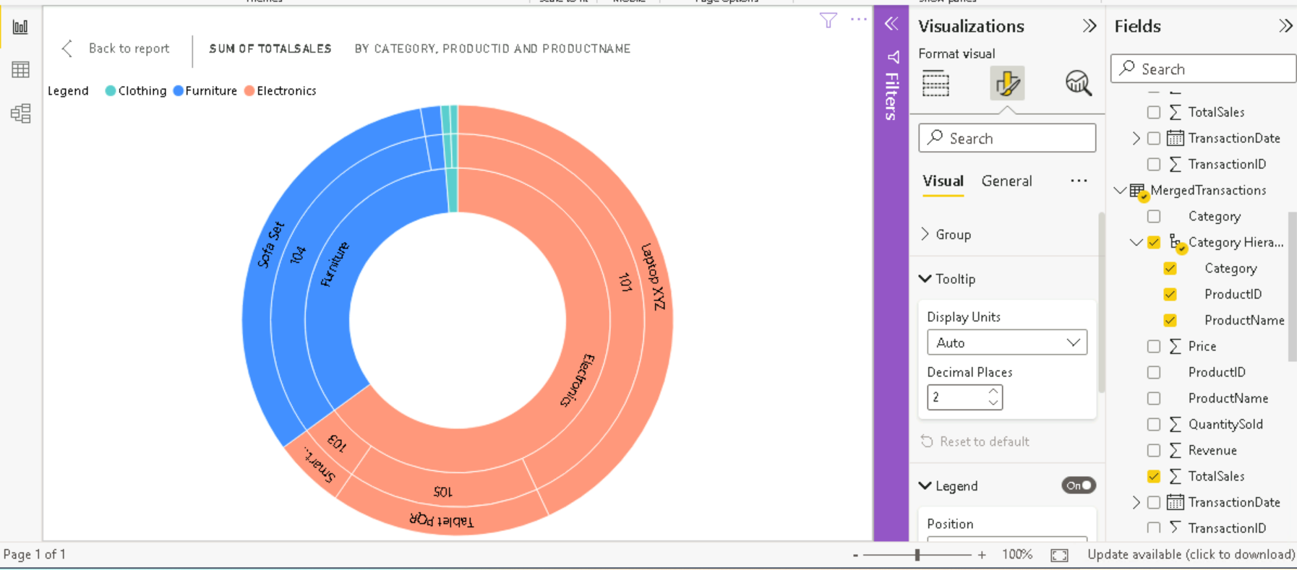

**Requirement 4: Business Queries and Analysis**

1. Who are the top-spending customers based on their total purchase amount?

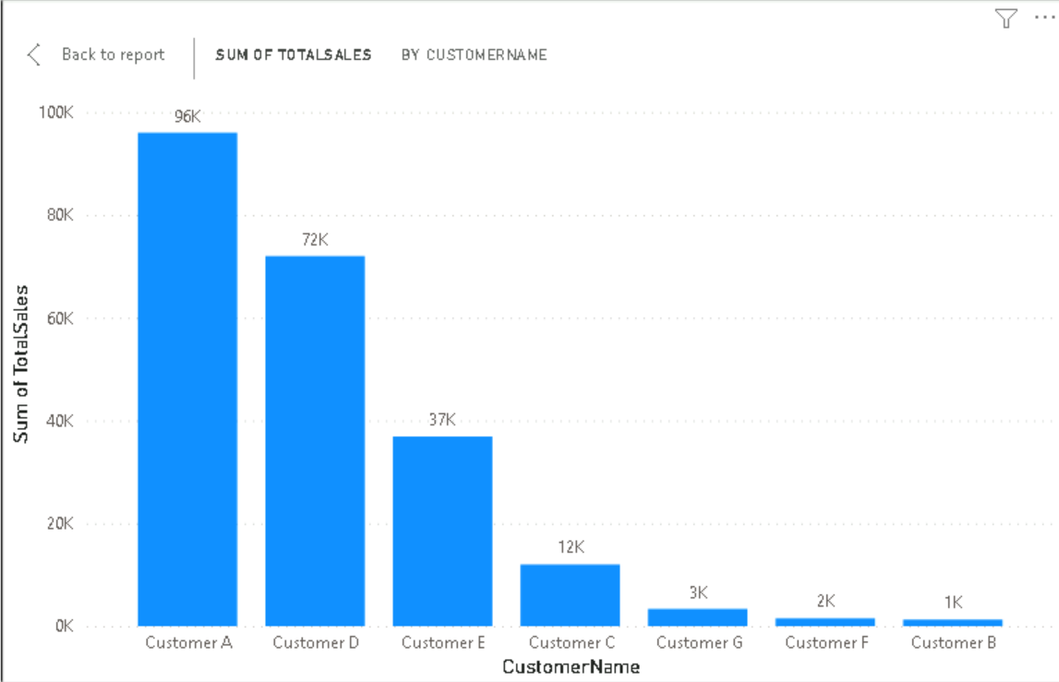

1. How is sales revenue distributed among different store managers?

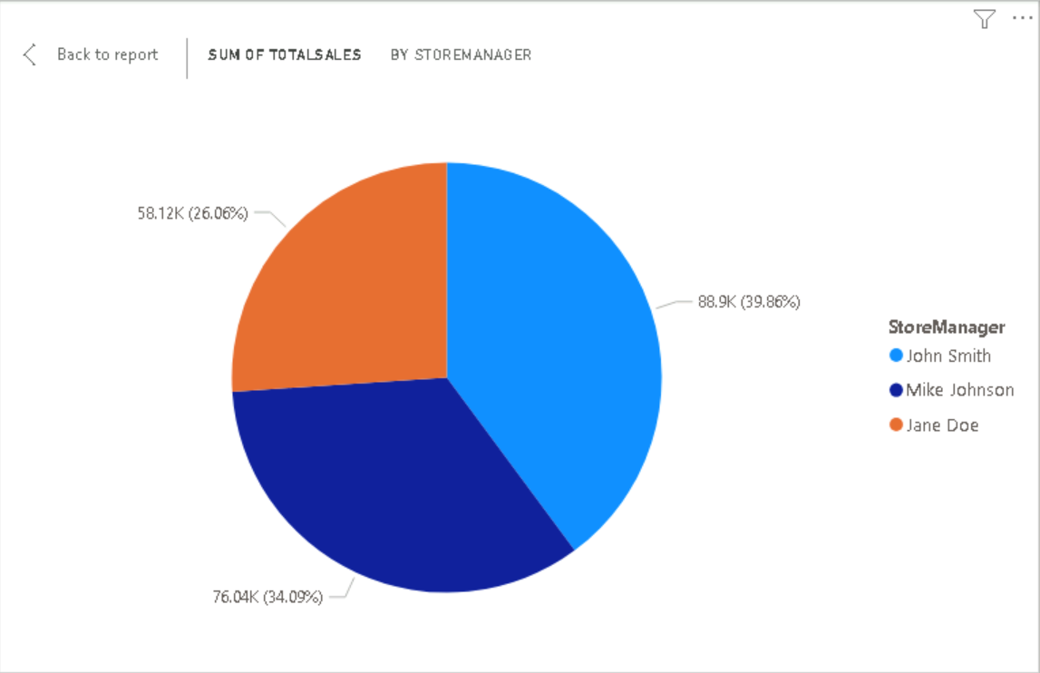

1. What is the average price of products in each category?

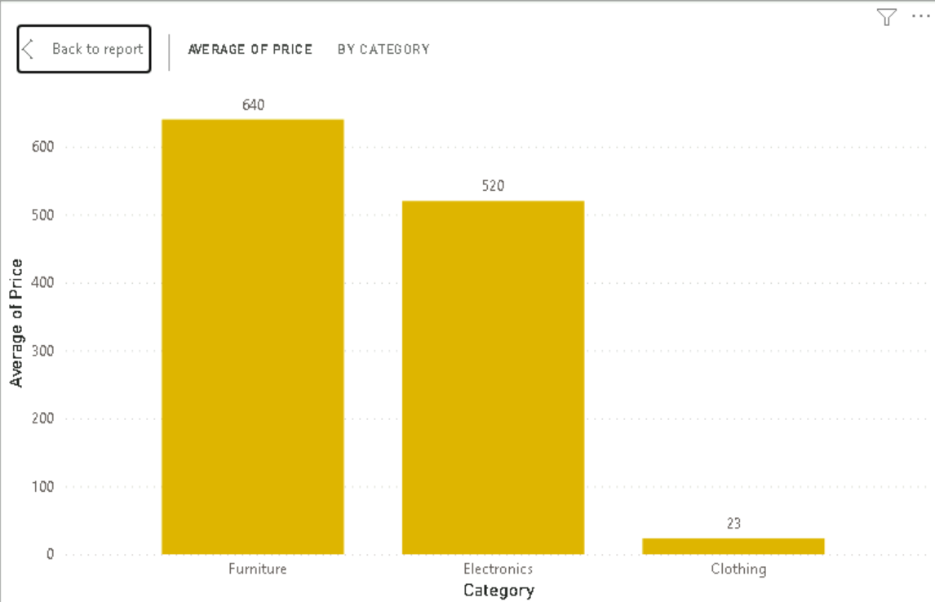

1. How do sales trends vary by product category on a monthly basis?

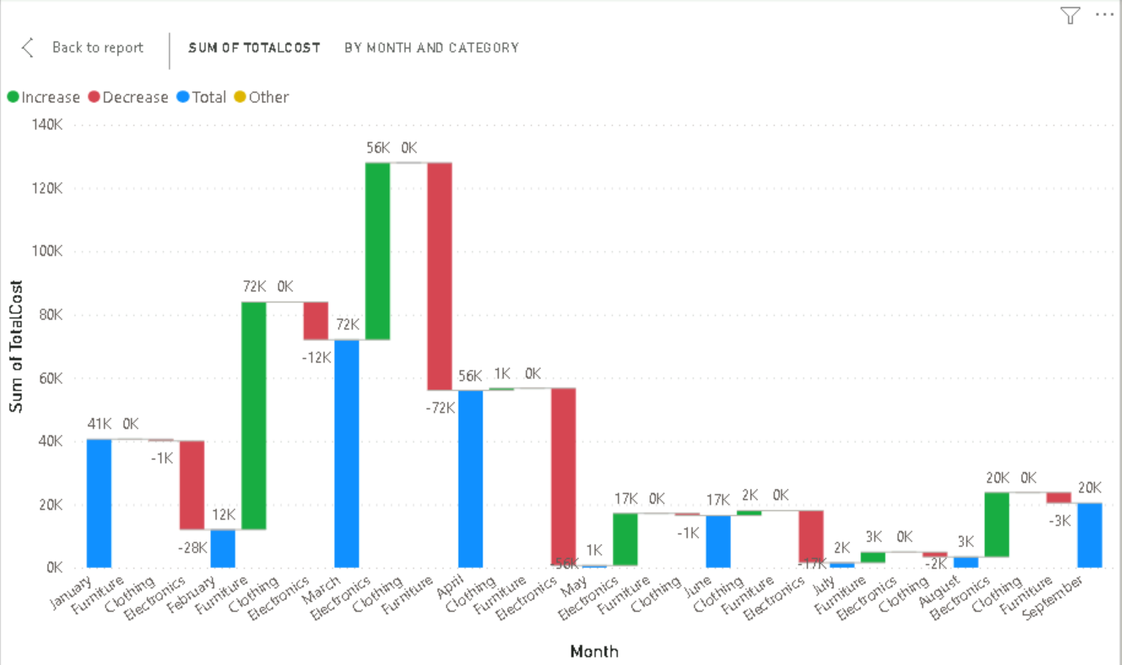

1. What percentage of products account for 80% of total sales revenue?

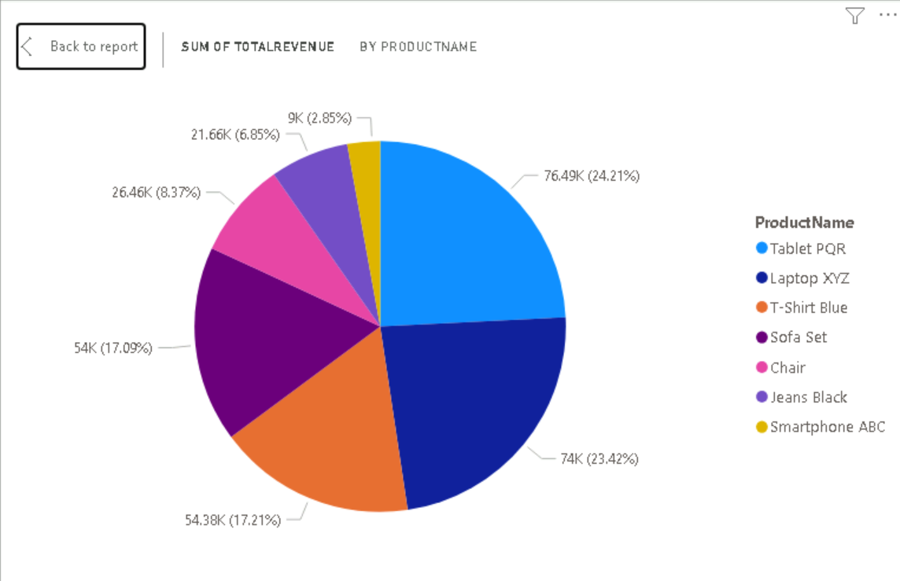

1. Which product categories perform best at each store location?

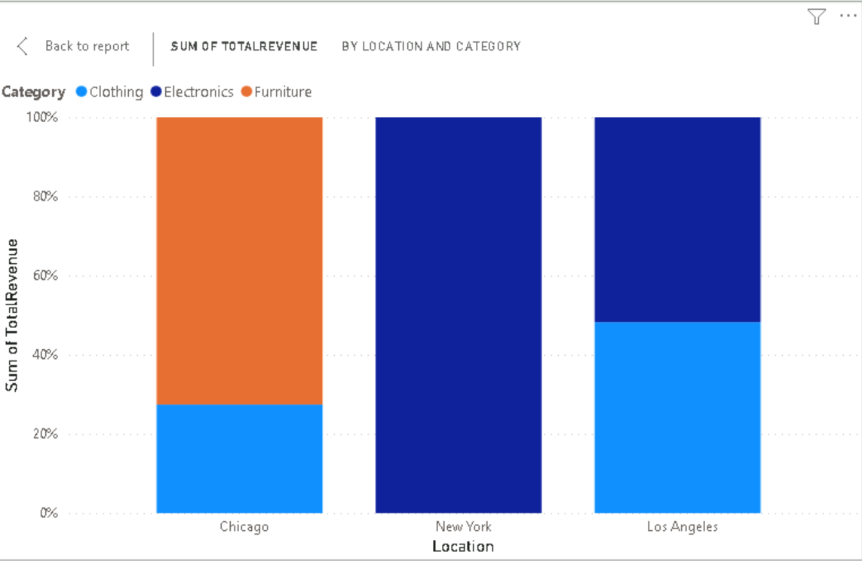

**Requirement 5**

Electronics items generate the most revenue.

